Task 10.Use Matplotlib module for plotting in python

Aim:
To use Matplotlib module for plotting in python.

Problem 10.1. Write a Python programming to display a bar chart of the popularity of programming Languages.
Sample data:
Programming languages: Java, Python, PHP, JavaScript, C#, C++
Popularity: 22.2, 17.6, 8.8, 8, 7.7, 6.7

Algorithm:
- Define two lists for programming languages and their popularity respectively
- Find the maximum popularity value in the list
- Define a scaling factor to scale the bar heights within a certain limit (e.g. 50 characters)
- For each language and popularity pair, calculate the bar height as the popularity value scaled by the scaling factor
- Print the chart using a loop to iterate over the programming language list: a. Print the language name and a separator character (e.g. "|") b. Use a loop to print the bar chart by printing the bar character (e.g. "*") a number of times equal to the bar height c. Print the popularity value with a separator character d. Print a newline character

Program:
#pip install matplotlib
import matplotlib.pyplot as plt

languages = ['Java', 'Python', 'PHP', 'JavaScript', 'C#', 'C++']
popularity = [22.2, 17.6, 8.8, 8, 7.7, 6.7]

plt.bar(languages, popularity, color='b')
plt.title('Popularity of Programming Languages')
plt.xlabel('Programming Languages')
plt.ylabel('Popularity')
plt.show()

Output:

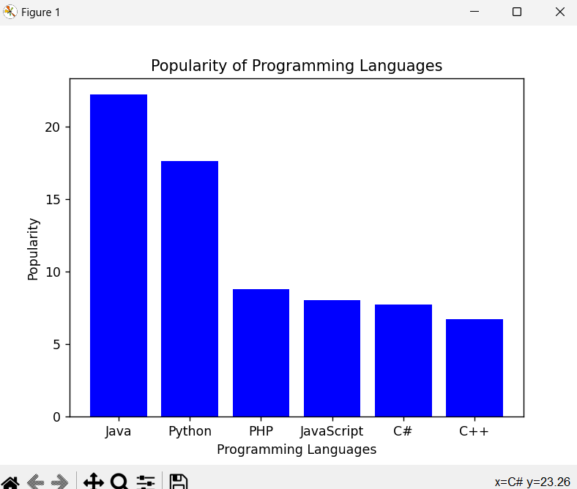

Problem 10.2.Write a Python programming to create a pie chart of the popularity of programming Languages.
Sample data:
Programming languages: Java, Python, PHP, JavaScript, C#, C++
Popularity: 22.2, 17.6, 8.8, 8, 7.7, 6.7

Algorithm:
- Create a list of Programming Languages and Popularity
- Create a pie chart using the matplotlib library
- Set the title and legend for the pie chart
- Show the pie chart

Program:
import matplotlib.pyplot as plt

# Step 1
languages = ['Java', 'Python', 'PHP', 'JavaScript', 'C#', 'C++']
popularity = [22.2, 17.6, 8.8, 8, 7.7, 6.7]

# Step 2
plt.pie(popularity, labels=languages, autopct='%1.1f%%')

# Step 3
plt.title('Popularity of Programming Languages')
plt.legend(languages, loc="best")

# Step 4
plt.show()

Output:

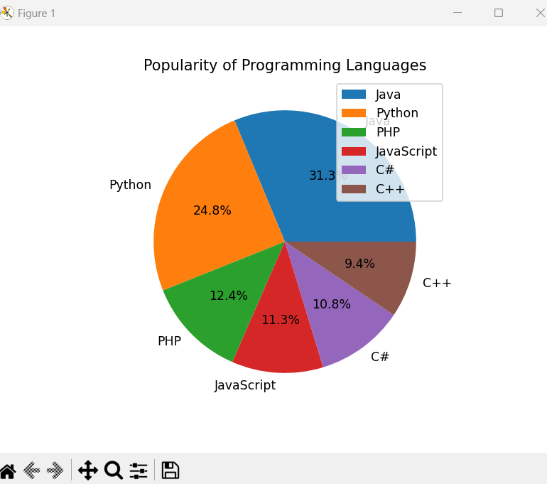

Problem 10.3. Write a Python programming to create a line graph showing marks of each student across all 4 tests.
Sample data:
Students.csv
Name,Test1,Test2,Test3,Test4
Alice,75,80,78,90
Bob,88,85,82,87
Charlie,60,65,70,68
David,92,95,90,94
Eva,70,72,75,78

Algorithm:
- Import libraries:
pandas for reading CSV data.
matplotlib.pyplot for plotting.
- Read CSV file using pd.read_csv("students.csv").
- Extract student names from the "Name" column for the x-axis.
- Plot each test’s marks as a separate line on the graph:
Use marker='s' for Test1, marker='o' for Test2, etc.
Use label parameter to name each line.
- Add labels, title, and legend:
plt.ylabel("Marks")
plt.title("Student Marks Across Tests")
plt.legend()
- Display the plot using plt.show().

Program:
import pandas as pd
import matplotlib.pyplot as plt

# Read CSV
df = pd.read_csv("students.csv")

# x-axis = student names
x = df["Name"]

# Plot each test as a separate line
plt.plot(x, df["Test1"], marker='s', label="Test1")
plt.plot(x, df["Test2"], marker='o', label="Test2")
plt.plot(x, df["Test3"], marker='*', label="Test3")
plt.plot(x, df["Test4"], marker='x', label="Test4")

plt.ylabel("Marks")
plt.title("Student Marks Across Tests")
plt.legend()
plt.show()

Output:
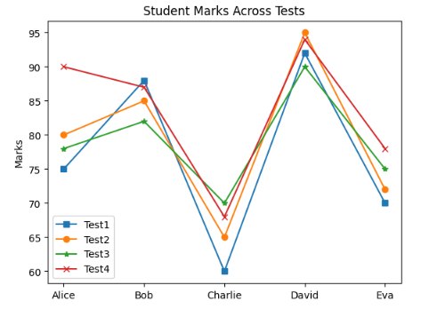

Result: Thus the python program use Matplotlib module for plotting is executed and verified successfully.

